**LSHS MUSIC DEPARTMENT TIE ORDER FORM**

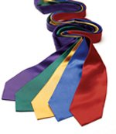

Students, you will need to order your official Lake Shore Concert Tie from us. It is a Kelly Green (our school color) Polyester Tie that is dry clean only so take good care of it.

Your cost is $15.00.

Please return this form to your high school music instructor by September 20th.

***Please pay by checks only. WE WILL NOT ACCEPT CASH!***

Checks should be made payable to the **Lake Shore Central Schools.**

Your tie will be given to you by your teacher as soon as they arrive.

-----------------------------------------------------------------------------------------------------

(please detach this portion of the form and return)

**NAME**

**HIGH SCHOOL MUSIC GROUP**

**PHONE NUMBER**

**QUANTITY** (number of ties ordered)

**AMOUNT PAID**